React Native Expo Project
Progress Log
Student Name: ____Katellyn Hyker____________________________________
App Name: ______InnerBloom__________________________________

Progress Made

Completed more of the actual design of the application. Homescreen and Journal screen have more of a completed layout. I have also started working on reconfiguring the original page navigation so that there will not be excessive bottom tabs. The journal screen will contain the methods on which the user can access the NewEntryScreen and the ViewEntryScreen.
Design Updates
Include screenshots or images of your app screens below.
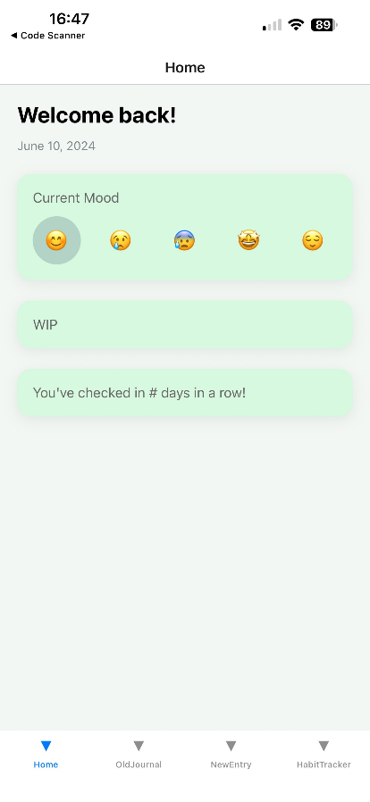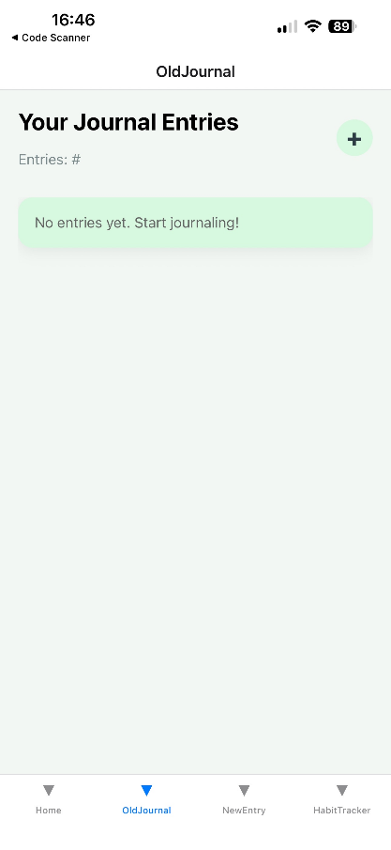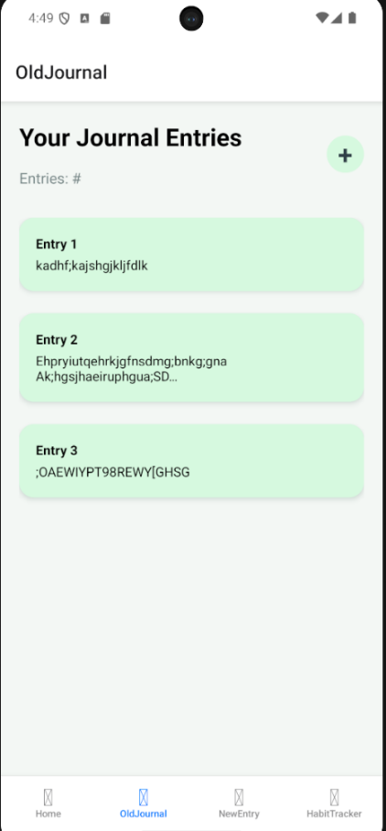
Issues / Blockers

Currently working through a major problem discovered when attempting to configure the new Journal entries related screens. Once I worked on the new navigation, upon trying to load the application on the android emulator or my personal iPhone through ExpoGo, when the JournalScreen is opened it shows an error page and the terminal outputs the following message:
ERROR [Error: Exception in HostFunction: TypeError: expected dynamic type 'boolean', but had type 'string'].
Along with that I also find this error message in the debugger:
C:\Users\llyn0\Desktop\Keiser\Cross-platform\InnerBloom-Journal-app\InnerBloom\node_modules\@react-native\js-polyfills\console.js:661 Error: Exception in HostFunction: TypeError: expected dynamic type 'boolean', but had type 'string'
at createNode (native)
at completeWork (192.168.1.54:8081/index.ts.bundle//&platform=ios&dev=true&hot=false&lazy=true&transform.routerRoot=app:30944:35)
at runWithFiberInDEV (192.168.1.54:8081/index.ts.bundle//&platform=ios&dev=true&hot=false&lazy=true&transform.routerRoot=app:26733:135)
at completeUnitOfWork (192.168.1.54:8081/index.ts.bundle//&platform=ios&dev=true&hot=false&lazy=true&transform.routerRoot=app:32499:36)
at performUnitOfWork (192.168.1.54:8081/index.ts.bundle//&platform=ios&dev=true&hot=false&lazy=true&transform.routerRoot=app:32437:44)
at workLoopSync (192.168.1.54:8081/index.ts.bundle//&platform=ios&dev=true&hot=false&lazy=true&transform.routerRoot=app:32328:57)
at renderRootSync (192.168.1.54:8081/index.ts.bundle//&platform=ios&dev=true&hot=false&lazy=true&transform.routerRoot=app:32312:21)
at performWorkOnRoot (192.168.1.54:8081/index.ts.bundle//&platform=ios&dev=true&hot=false&lazy=true&transform.routerRoot=app:32083:53)
at performSyncWorkOnRoot (192.168.1.54:8081/index.ts.bundle//&platform=ios&dev=true&hot=false&lazy=true&transform.routerRoot=app:28082:24)
at flushSyncWorkAcrossRoots_impl (192.168.1.54:8081/index.ts.bundle//&platform=ios&dev=true&hot=false&lazy=true&transform.routerRoot=app:28002:329)
at processRootScheduleInMicrotask (192.168.1.54:8081/index.ts.bundle//&platform=ios&dev=true&hot=false&lazy=true&transform.routerRoot=app:28021:36)
at anonymous (192.168.1.54:8081/index.ts.bundle//&platform=ios&dev=true&hot=false&lazy=true&transform.routerRoot=app:28093:184) Error Stack:
at RNSScreen (<anonymous>)
Next Steps

Before I try to continue anything else I want to try to fix the error that I am receiving. As of now the error messages I am receiving are not incredibly helpful as currently I don’t see the issue being within my own code. I believe it has something to do with the actual navigation features I am using since I have ran into a similar problem before. (The fix for that problem did not work this time.)
After that I plan to finish the design layouts for the other pages I did not get a chance to really work on yet. I already have some ideas written out in a notebook for them, it is just finalizing the ideas and setting up the Screens to reflect that.

